DP Algorithms for RNA Secondary Structure Prediction with Pseudoknots
Tasuya Akutsu
Discrete Applied Mathematics, Volume: 104, Issue: 1-3, August 15, 2000, pp. 45-62
Abstract
This paper describe simple dynamic programming algorithms for RNA secondary structure prediction with pseudoknots, for which no explicit DP algorithm had been known.
- Introduction
- A Dynamic Programming for Simple Pseudoknots
DP algorithms without pseudoknots:
f(i, j) = -1, if (i, j) is a base pair, otherwise 0.
S(i, j) = min{ S(i+1, j-1) + f(i, j), 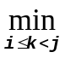{S(i, k) + S(k+1, j)}}.
Time: O(n³)
DP algorithms with pseudoknots:
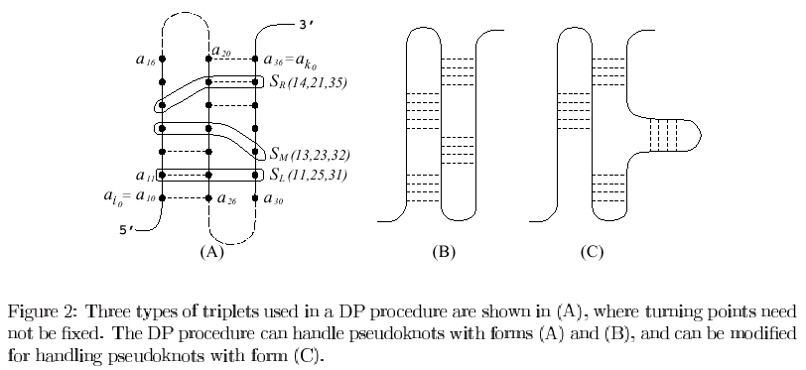
S_{L}(i,j,k)=min{ S_{L}(i-1,j+1,k), S_{M}(i-1,j+1,k), S_{R}(i-1, j+1, k)}+g(i, j),
S_{R}(i,j,k)=min{ S_{L}(i,j+1,k-1), S_{M}(i,j+1,k-1), S_{R}(i, j+1, k-1)}+g(j, k),
S_{M}(i,j,k)=min{S_{M}(i-1,j,k), S_{M}(i,j+1,k), S_{M}(i,j,k-1), S_{L}(i-1,j,k),
S_{L}(i,j+1,k), S_{R}(i,j+1,k), S_{R}(i,j,k-1)}+g(i, j),
g(i, j) = -1 if (i, j) is a base pair, otherwise
Initialization:
S_{L}(i₀, j, j+1) = g(i₀, j) for all j
S_{R}(i₀, j, j+1) = g(j, j+1) for all j
S_{L}(i₀, j, k) = S_{R}(i₀, j, k) = S_{M}(i₀, j, k) = 0 for the other j, k satisfying
k = j or k = j+1
S_{pseudo}(i₀, k₀) = 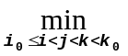min{S_{L}(i, j, k), S_{R}(i, j, k), S_{M}(i, j, k)}
S(i, j) = min{S_{pseudo}(i, j), S(i+1, j-1)+f(i, j),{S(i, k) + S(k+1, j)}}.
Time: O(n⁴)
Space: O(n³)
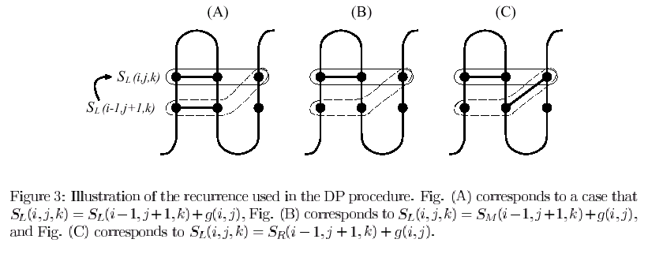
- Extension and Limitation
- Computational Experiments
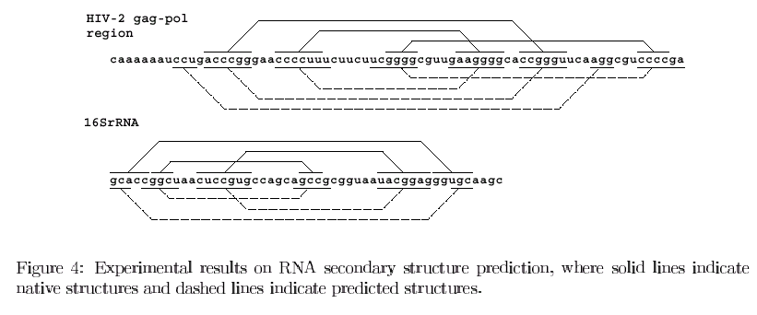
- Conclusion
Created by : Ming-Cheng Lin
Date: Nov. 28, 2000

